谷粒商城

版本：V 1.0

订单

# 业务介绍

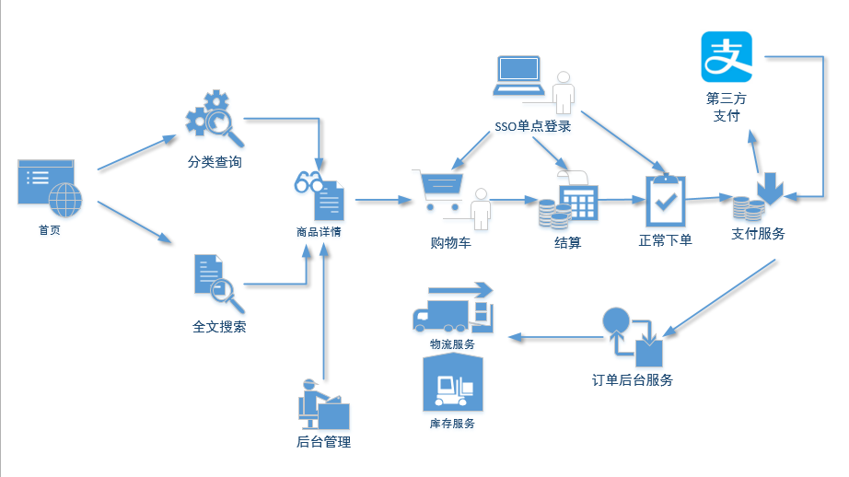

**当前的位置**

订单业务在整个电商平台中处于核心位置，也是比较复杂的一块业务。是把“物”变为“钱”的一个中转站。

整个订单模块一共分四部分组成：

1. 结算
2. 下单
3. 对接支付服务
4. 对接库存管理系统：

# 结算页

入口：购物车点击计算按钮 ，结算必须要登录！

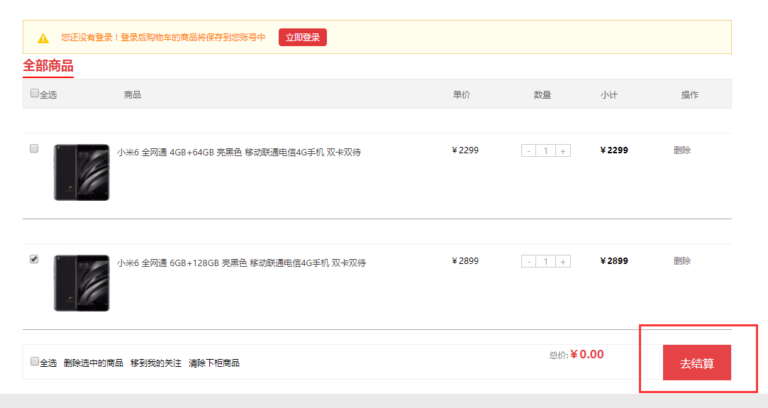

## 1 搭建模块

### 1.1 gmall-order-web（模块已添加）

application.properties

|  |
| --- |
| **spring.dubbo.application.name**=**order-web spring.dubbo.registry.protocol**=**zookeeper spring.dubbo.registry.address**=**192.168.67.202:2181 spring.dubbo.base-package**=**com.atguigu.gmall spring.dubbo.protocol.name**=**dubbo spring.dubbo.consumer.timeout**=**10000 spring.dubbo.consumer.check**=**false  server.port**=**8081 spring.thymeleaf.cache**=**false spring.thymeleaf.mode**=**LEGACYHTML5**  **mapper.enum-as-simple-type**=**true** |

拷贝静态资源文件和html

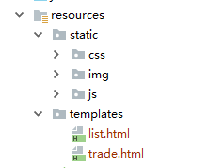

host文件

|  |
| --- |
| # gmall  192.168.67.163 cart.gmall.com passport.atguigu.com item.gmall.com list.gmall.com manage.gmall.com www.gmall.com resource.gmall.com order.gmall.com |

nginx.conf

|  |
| --- |
| upstream order.gmall.com{  server 192.168.67.1:8081;  }  server {  listen 80;  server_name order.gmall.com;  location / {  proxy_pass http://order.gmall.com;  proxy_set_header X-forwarded-for $proxy_add_x_forwarded_for;  }  } |

## 2 分析

分析页面需要的数据：

1. 得到用户信息
2. 购物车中选择的商品列表

## 3 购物车中选择的商品列表

结算的时候，需要将信息添加到OrderDetail 表中！

### 3.1 订单的数据结构：

orderInfo ：订单表

orderDetail ：订单明细

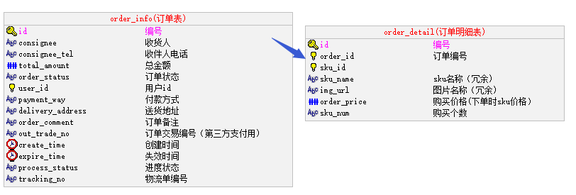

|  |  |
| --- | --- |
| id | 主键。自动生成 |
| consignee | 收货人名称。页面获取 |
| consignee_tel | 收货人电话。页面获取 |
| deliveryAddress | 收货地址。页面获取 |
| total_amount | 总金额。计算 |
| order_status | 订单状态，用于显示给用户查看。设定初始值。 |
| userId | 用户Id。从拦截器已放到请求属性中。 |
| payment_way | 支付方式（网上支付、货到付款）。页面获取 |
| orderComment | 订单状态。页面获取 |
| out_trade_no | 第三方支付编号。按规则生成 |
| create_time | 创建时间。设当前时间 |
| expire_time | 默认当前时间+1天 |
| process_status | 订单进度状态，程序控制、 后台管理查看。设定初始值， |
| tracking_no | 物流编号,初始为空，发货后补充 |
| parent_order_id | 拆单时产生，默认为空 |

|  |  |
| --- | --- |
| id | 主键，自动生成 |
| order_id | 订单编号，主表保存后给从表 |
| sku_id | 商品id 页面传递 |
| sku_name | 商品名称，后台添加 |
| img_url | 图片路径，后台添加 |
| order_price | 商品单价，从页面中获取，并验价。 |
| sku_num | 商品个数，从页面中获取 |

增加实体Bean

|  |
| --- |
| **public class** OrderInfo **implements** Serializable { @Column @Id @GeneratedValue(strategy = GenerationType.***IDENTITY***) **private** String **id**;  @Column **private** String **consignee**;  @Column **private** String **consigneeTel**;   @Column **private** BigDecimal **totalAmount**;  @Column **private** OrderStatus **orderStatus**;  @Column **private** ProcessStatus **processStatus**;   @Column **private** String **userId**;  @Column **private** PaymentWay **paymentWay**;  @Column **private** Date **expireTime**;  @Column **private** String **deliveryAddress**;  @Column **private** String **orderComment**;  @Column **private** Date **createTime**;  @Column **private** String **parentOrderId**;  @Column **private** String **trackingNo**;   @Transient **private** List<OrderDetail> **orderDetailList**;   @Transient **private** String **wareId**;  @Column **private** String **outTradeNo**;  **public void** sumTotalAmount(){  BigDecimal totalAmount=**new** BigDecimal(**"0"**);  **for** (OrderDetail orderDetail : **orderDetailList**) {  totalAmount= totalAmount.add(orderDetail.getOrderPrice().multiply(**new** BigDecimal(orderDetail.getSkuNum())));  }  **this**.**totalAmount**= totalAmount; }  } |

增加枚举类

枚举类路径放到gmall-bean 模块中和bean同级目录。

在bean下建立order_detail

|  |
| --- |
| **public class** OrderDetail **implements** Serializable {  @Id  @Column  **private** String **id**;  @Column  **private** String **orderId**;  @Column  **private** String **skuId**;  @Column  **private** String **skuName**;  @Column  **private** String **imgUrl**;  @Column  **private** BigDecimal **orderPrice**;  @Column  **private** Integer **skuNum**;   @Transient  **private** String **hasStock**;  } |

其中hasStock是一个非持久化属性，用户传递【是否还有库存】的标志。

如果商品在库存中有足够数据，suceess = “1”，fail=“0”

### 3.2 OrderController

加入tradeInit方法

|  |
| --- |
| @Reference **private** CartService **cartService**;  @RequestMapping(value = **"trade"**,method = RequestMethod.***GET***) @LoginRequire **public** String tradeInit(HttpServletRequest request){  String userId = (String) request.getAttribute(**"userId"**);  *// 得到选中的购物车列表* List<CartInfo> cartCheckedList = **cartService**.getCartCheckedList(userId);  *// 收货人地址* List<UserAddress> userAddressList = **userInfoService**.getUserAddressList(userId);  request.setAttribute(**"userAddressList"**,userAddressList);  *// 订单信息集合* List<OrderDetail> orderDetailList=**new** ArrayList<>(cartCheckedList.size());  **for** (CartInfo cartInfo : cartCheckedList) {  OrderDetail orderDetail = **new** OrderDetail();  orderDetail.setSkuId(cartInfo.getSkuId());  orderDetail.setSkuName(cartInfo.getSkuName());  orderDetail.setImgUrl(cartInfo.getImgUrl());  orderDetail.setSkuNum(cartInfo.getSkuNum());  orderDetail.setOrderPrice(cartInfo.getCartPrice());  orderDetailList.add(orderDetail);  }  request.setAttribute(**"orderDetailList"**,orderDetailList);  OrderInfo orderInfo=**new** OrderInfo(); orderInfo.setOrderDetailList(orderDetailList); orderInfo.sumTotalAmount(); request.setAttribute(**"totalAmount"**,orderInfo.getTotalAmount());  **return "trade"**; } |

### 3.1 在CartServiceImpl.java

|  |
| --- |
| *// 得到选中购物车列表* **public** List<CartInfo> getCartCheckedList(String userId){  *// 获得redis中的key* String userCheckedKey = CartConst.***USER_KEY_PREFIX*** + userId + CartConst.***USER_CHECKED_KEY_SUFFIX***;  Jedis jedis = **redisUtil**.getJedis();  List<String> cartCheckedList = jedis.hvals(userCheckedKey);  List<CartInfo> newCartList = **new** ArrayList<>();  **for** (String cartJson : cartCheckedList) {  CartInfo cartInfo = JSON.*parseObject*(cartJson,CartInfo.**class**);  newCartList.add(cartInfo);  }  **return** newCartList; } |
| **接口**CartService  **public** List<CartInfo> getCartCheckedList(String userId) |

### 3.4 结算页面

|  |
| --- |
| *<!--地址-->* <**div class="top-3"**>  <**ul** >  <**li class=".address default selected" th:each="userAddress :${userAddressList}"** >  <**input name="deliveryAddress" type="radio" value="" th:checked="${userAddress.isDefault}=='1'" checked="true"**>  <**span th:text="${userAddress.consignee}"** >收件人AAAA </**span**><**span th:text="${userAddress.userAddress}"** >具体地址111 </**span**>  </**li**>  </**ul**> </**div**> |

商品清单部分

|  |
| --- |
| <**div class="to_right"**>  <**h5**>商家：自营</**h5**>  *<!--图片-->* <**div class="yun1" th:each="orderDetail: ${orderDetailList}"** >  <**img src="" th:src="${orderDetail.imgUrl}" class="yun"**/>  <**div class="mi"**>  <**div**><**p style="width**: 500**px**;**" th:text="${orderDetail.skuName}"**>商品名称111111111111 </**p**> <**span style="float**: **right"**> <**span align="center" style="color**: **red"** > </**span**> <**span th:text="'X'+${orderDetail.skuNum}"** > X 1 </**span**> <**span** >有货</**span**> <**span** >无货</**span**> </**span**> </**div**>  </**div**>  </**div**>  </**div**> |

总价钱

|  |
| --- |
| <**p class="yfze_a"**><**span class="z"**>应付总额：</**span**><**span class="hq" th:text="'￥'+${totalAmount}"** > ￥99999</**span**></**p**> |

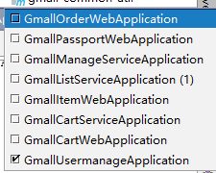

# 三、下订单

## 1 数据结构

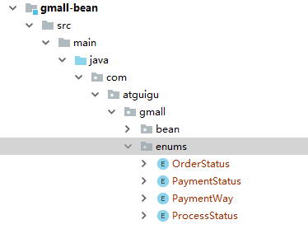

|  |
| --- |
| **public enum** OrderStatus {  ***UNPAID***(**"未支付"**),  ***PAID***(**"已支付"** ),  ***WAITING_DELEVER***(**"待发货"**),  ***DELEVERED***(**"已发货"**),  ***CLOSED***(**"已关闭"**),  ***FINISHED***(**"已完结"**) ,  ***SPLIT***(**"订单已拆分"**);   **private** String **comment** ;    OrderStatus(String comment ){  **this**.**comment**=comment;  }   **public** String getComment() {  **return comment**;  }   **public void** setComment(String comment) {  **this**.**comment** = comment;  }   } |

|  |
| --- |
| **public enum** ProcessStatus {  ***UNPAID***(**"未支付"**,OrderStatus.***UNPAID***),  ***PAID***(**"已支付"**,OrderStatus.***PAID***),  ***NOTIFIED_WARE***(**"已通知仓储"**,OrderStatus.***PAID***),  ***WAITING_DELEVER***(**"待发货"**,OrderStatus.***WAITING_DELEVER***),  ***STOCK_EXCEPTION***(**"库存异常"**,OrderStatus.***PAID***),  ***DELEVERED***(**"已发货"**,OrderStatus.***DELEVERED***),  ***CLOSED***(**"已关闭"**,OrderStatus.***CLOSED***),  ***FINISHED***(**"已完结"**,OrderStatus.***FINISHED***) ,  ***PAY_FAIL***(**"支付失败"**,OrderStatus.***UNPAID***),  ***SPLIT***(**"订单已拆分"**,OrderStatus.***SPLIT***);   **private** String **comment** ;  **private** OrderStatus **orderStatus**;   ProcessStatus(String comment, OrderStatus orderStatus){  **this**.**comment**=comment;  **this**.**orderStatus**=orderStatus;  }   **public** String getComment() {  **return comment**;  }   **public void** setComment(String comment) {  **this**.**comment** = comment;  }   **public** OrderStatus getOrderStatus() {  **return orderStatus**;  }   **public void** setOrderStatus(OrderStatus orderStatus) {  **this**.**orderStatus** = orderStatus;  } |

|  |
| --- |
| **public enum** PaymentWay {  ***ONLINE***(**"在线支付"**),  ***OUTLINE***(**"货到付款"** );   **private** String **comment** ;    PaymentWay(String comment ){  **this**.**comment**=comment;  }   **public** String getComment() {  **return comment**;  }   **public void** setComment(String comment) {  **this**.**comment** = comment;  }   } |

由于涉及枚举类所以 application.properties中要加入

|  |
| --- |
| **mapper.enum-as-simple-type**=**true** |

这个配置会把枚举类当成字符串处理。

## 2 分析下单：

1. 保存单据前要做交易：验库存。
2. 保存单据: orderInfo orderDetail。
3. 保存以后把购物车中的商品删除。
4. 重定向到支付页面。

## 3 订单后台服务模块

### 3.1 搭建gmall-order-service

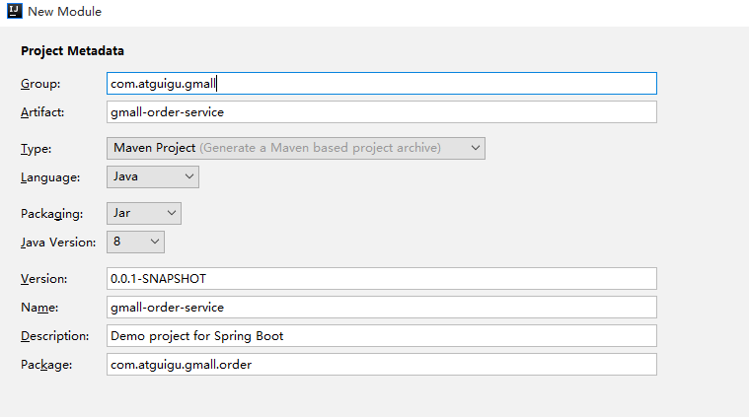

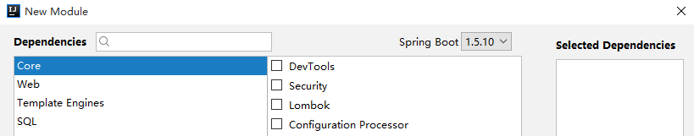

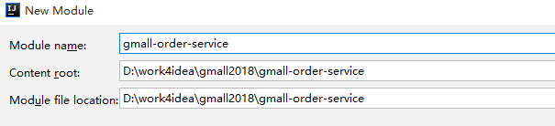

#### pom.xml

|  |
| --- |
| *<?*xml version="1.0" encoding="UTF-8"*?>* <project xmlns="http://maven.apache.org/POM/4.0.0" xmlns:xsi="http://www.w3.org/2001/XMLSchema-instance"  xsi:schemaLocation="http://maven.apache.org/POM/4.0.0 http://maven.apache.org/xsd/maven-4.0.0.xsd">  <modelVersion>4.0.0</modelVersion>   <groupId>com.atguigu.gmall</groupId>  <artifactId>gmall-order-service</artifactId>  <version>0.0.1-SNAPSHOT</version>  <packaging>jar</packaging>   <name>gmall-order-service</name>  <description>Demo project for Spring Boot</description>   <parent>  <groupId>com.atguigu.gmall</groupId>  <artifactId>gmall-parent</artifactId>  <version>1.0-SNAPSHOT</version>  </parent>  <dependencies>   <dependency>  <groupId>com.atguigu.gmall</groupId>  <artifactId>gmall-interface</artifactId>  <version>1.0-SNAPSHOT</version>  </dependency>   <dependency>  <groupId>com.atguigu.gmall</groupId>  <artifactId>gmall-service-util</artifactId>  <version>1.0-SNAPSHOT</version>  </dependency>  </dependencies>   <build>  <plugins>  <plugin>  <groupId>org.springframework.boot</groupId>  <artifactId>spring-boot-maven-plugin</artifactId>  </plugin>  </plugins>  </build>   </project> |

#### application.properties

|  |
| --- |
| server.port=8090  logging.level.root=debug  spring.dubbo.application.name=order-service spring.dubbo.registry.protocol=zookeeper spring.dubbo.registry.address=192.168.67.202:2181 spring.dubbo.base-package=com.atguigu.gmall spring.dubbo.protocol.name=dubbo spring.dubbo.consumer.timeout=100000 spring.dubbo.consumer.check=false  spring.datasource.url=jdbc:mysql://localhost:3306/gmall?characterEncoding=UTF-8 spring.datasource.username=root spring.datasource.password=root   mybatis.mapper-locations=classpath:mapper/*Mapper.xml mybatis.configuration.mapUnderscoreToCamelCase=true  spring.redis.host=192.168.67.202 spring.redis.port=6379 spring.redis.database=0  **mapper.enum-as-simple-type**=**true** |

GmallOrderServiceApplication

|  |
| --- |
| @SpringBootApplication @MapperScan(basePackages = **"com.atguigu.gmall.order.mapper"**) @ComponentScan(basePackages = **"com.atguigu.gmall"**) **public class** GmallOrderServiceApplication {   **public static void** main(String[] args) {  SpringApplication.*run*(GmallOrderServiceApplication.**class**, args);  } } |

### 3.2 OrderService

|  |
| --- |
| **接口：返回orderId，保存完，应该调到支付，根据orderId。**  **public String** saveOrder(OrderInfo orderInfo); |
| **Mapper：**  **public interface** OrderInfoMapper **extends** Mapper<OrderInfo>{   } |

### 3.3 OrderServiceImpl

|  |  |
| --- | --- |
| @Service **public class** OrderServiceImpl **implements** OrderService{   @Autowired  **private** OrderInfoMapper **orderInfoMapper**;  @Autowired  **private** OrderDetailMapper **orderDetailMapper**;     **public String** saveOrder(OrderInfo orderInfo){  *// 设置创建时间* orderInfo.setCreateTime(**new** Date());  *// 设置失效时间* Calendar calendar = Calendar.*getInstance*();  calendar.add(Calendar.***DATE***,1);  orderInfo.setExpireTime(calendar.getTime());  *// 生成第三方支付编号* String outTradeNo=**"ATGUIGU"**+System.*currentTimeMillis*()+**""**+**new** Random().nextInt(1000);  orderInfo.setOutTradeNo(outTradeNo);  **orderInfoMapper**.insertSelective(orderInfo);   *// 插入订单详细信息* List<OrderDetail> orderDetailList = orderInfo.getOrderDetailList();  **for** (OrderDetail orderDetail : orderDetailList) {  orderDetail.setOrderId(orderInfo.getId());  **orderDetailMapper**.insertSelective(orderDetail);  }  *// 为了跳转到支付页面使用。支付会根据订单id进行支付。* String orderId = orderInfo.getId(); **return** orderId;  } |  |

### 3.4 OrderController

|  |
| --- |
| @RequestMapping(value = **"submitOrder"**,method = RequestMethod.***POST***) @LoginRequire **public** String submitOrder(OrderInfo orderInfo,HttpServletRequest request){  *// 检查tradeCode* String userId = (String) request.getAttribute(**"userId"**);  *// 初始化参数* orderInfo.setOrderStatus(OrderStatus.***UNPAID***);  orderInfo.setProcessStatus(ProcessStatus.***UNPAID***);  orderInfo.sumTotalAmount();  orderInfo.setUserId(userId);  *// 保存* String orderId = **orderService**.saveOrder(orderInfo);  *// 重定向* **return "redirect://payment.gmall.com/index?orderId="**+orderId; } |

### 3.5 页面trade.html

|  |
| --- |
| <**form action="./submitOrder" method="post" id="orderForm"**>  <**input name="consignee" id="consignee" type="hidden"**/>  <**input name="deliveryAddress" id="deliveryAddress" type="hidden"**/>  <**input name="paymentWay" id="paymentWay" type="hidden"**/>  <**input name="orderComment" id="orderComment" type="hidden"**/>  <**span th:each="orderDetail,stat: ${orderDetailList}"** >  <**input th:name="'orderDetailList['+${stat.index}+'].skuId'" type="hidden" th:value="${orderDetail.skuId}"** />  <**input th:name="'orderDetailList['+${stat.index}+'].skuNum'" type="hidden" th:value="${orderDetail.skuNum}"** />  <**input th:name="'orderDetailList['+${stat.index}+'].orderPrice'" type="hidden" th:value="${orderDetail.orderPrice}"** />  <**input th:name="'orderDetailList['+${stat.index}+'].skuName'" type="hidden" th:value="${orderDetail.skuName}"** />  </**span**>  <**input name="tradeNo" type="hidden" value="1"** /> </**form**> <**script**>  *$*(**function**() {   *$*(**"#submitButton"**).click(**function** () {  *// 收货人  $*(**"#consignee"**).val(*$*(**"input[type='radio']:checked"**).next().text()) ;  *// 收获地址  $*(**"#deliveryAddress"**).val( *$*(**"input[type='radio']:checked"**).next().next().text());  *$*(**"#paymentWay"**).val(**"ONLINE"**);  *// 订单备注  $*(**"#orderComment"**).val(*$*(**"#orderCommentPage"**).val());  **console**.log(*$*(**"#orderForm"**).html());  *$*(**"#orderForm"**).submit();   }); |

## 4 如何解决用户利用浏览器回退重复提交订单？

在进入结算页面时，生成一个结算流水号，然后保存到结算页面的隐藏元素中，每次用户提交都检查该流水号与页面提交的是否相符，订单保存以后把后台的流水号删除掉。那么第二次用户用同一个页面提交的话流水号就会匹配失败，无法重复保存订单。

### 4.1 修改结算页增加流水号的生成。

#### 4.1.1 OrderServiceImpl

|  |
| --- |
| *// 生成流水号* **public** String getTradeNo(String userId){  Jedis jedis = **redisUtil**.getJedis();  String tradeNoKey=**"user:"**+userId+**":tradeCode"**;  String tradeCode = UUID.*randomUUID*().toString();  jedis.setex(tradeNoKey,10*60,tradeCode);  jedis.close();  **return** tradeCode; }  *// 验证流水号* **public boolean** checkTradeCode(String userId,String tradeCodeNo){  Jedis jedis = **redisUtil**.getJedis();  String tradeNoKey = **"user:"**+userId+**":tradeCode"**;  String tradeCode = jedis.get(tradeNoKey);  jedis.close();  **if** (tradeCode!=**null** && tradeCode.equals(tradeCodeNo)){  **return true**;  }**else**{  **return false**;  } } *// 删除流水号* **public void** delTradeCode(String userId){  Jedis jedis = **redisUtil**.getJedis();  String tradeNoKey = **"user:"**+userId+**":tradeCode"**;  jedis.del(tradeNoKey);  jedis.close(); } |
| *将三个方法添加到接口中* |

4.1.2 在OrderController中添加tradeInit方法保存code编码

|  |
| --- |
| *// 获取TradeCode号* String tradeNo = **orderService**.getTradeNo(userId); request.setAttribute(**"tradeCode"**,tradeNo); |
| *在页面表单提交的时候，将TradeNo进行保存* |

### 4.2 OrderController中的submitOrder方法中

|  |
| --- |
| @RequestMapping(value = **"submitOrder"**,method = RequestMethod.***POST***) @LoginRequire **public** String submitOrder(OrderInfo orderInfo,HttpServletRequest request){  String userId = (String) request.getAttribute(**"userId"**);  *// 检查tradeCode* String tradeNo = request.getParameter(**"tradeNo"**);  **boolean** flag = **orderService**.checkTradeCode(userId, tradeNo);  **if** (!flag){  request.setAttribute(**"errMsg"**,**"该页面已失效，请重新结算!"**);  **return "tradeFail"**;  }  *// 初始化参数* orderInfo.setOrderStatus(OrderStatus.***UNPAID***);  orderInfo.setProcessStatus(ProcessStatus.***UNPAID***);  orderInfo.sumTotalAmount();  orderInfo.setUserId(userId);  String orderId = **orderService**.saveOrder(orderInfo);  *// 删除tradeNo*  **orderService**.delTradeNo(userId);  **return "redirect://payment.gmall.com/index?orderId="**+orderId;  } |

## 5 验库存

通过restful接口查询商品是否有库存

一般电商系统的商品库存，都不由电商系统本身来管理，由另外一套仓库管理系统，或者进销存系统来管理，电商系统通过第三方接口调用该系统。

由于库管系统可能是异构的系统，所以不在dubbo的分布式体系之内。只支持restful风格的webservice调用和消息队列的调用。

详见《库存管理系统手册》

根据手册中的接口文档，编写调用代码。

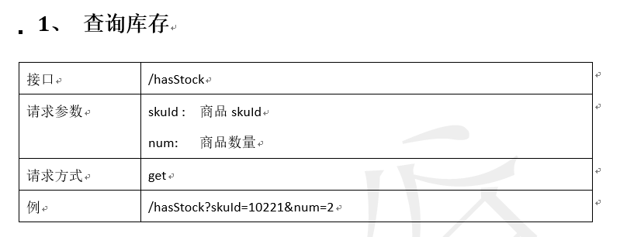

### 导入项目gware-manage项目

详情查看库存管理系统文档

导入 相应的数据库表

|  |
| --- |
| create table ware_info  (  id bigint /*auto_increment*/ not null,  name VARCHAR(200),  address VARCHAR(200),  areacode VARCHAR(20)  );  alter table ware_info  add constraint PK_ware_info_id primary key (id); |

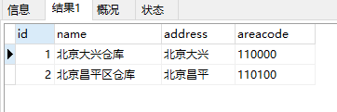

|  |
| --- |
| create table ware_sku  (  id bigint /*auto_increment*/ not null,  sku_id bigint,  warehouse_id bigint,  stock int,  stock_name VARCHAR(200),  stock_locked INTEGER  );  alter table ware_sku  add constraint PK_ware_sku_id primary key (id); |

填写库存信息！

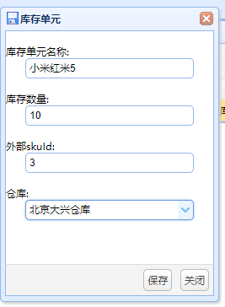

需要配置nginx

|  |
| --- |
| upstream www.gware.com {  server 192.168.67.1:9001;  }  server {  listen 80;  server_name www.gware.com;  location /{  proxy_pass http://www.gware.com;  proxy_set_header X-forwarded-for $proxy_add_x_forwarded_for;  }  } |

### 查询仓库数量，进行校验

现在验证库存数量方法

在orderService接口中定义验库存接口

|  |
| --- |
| **boolean** checkStock(String skuId, Integer skuNum); |

实现类OrderServiceImpl

|  |
| --- |
| *// 验证库存* **private boolean** checkStock(String skuId,Integer skuNum){  String result = HttpClientUtil.*doGet*(**"http://www.gware.com/hasStock?skuId="** + skuId + **"&num="** + skuNum);  **if** (**"1"**.equals(result)){  **return true**;  }**else** {  **return false**;  } } |

### 5.3 submitOrder中增加 方法

|  |
| --- |
| @RequestMapping(value = **"submitOrder"**,method = RequestMethod.***POST***) @LoginRequire **public** String submitOrder(OrderInfo orderInfo,HttpServletRequest request){  String userId = (String) request.getAttribute(**"userId"**);  *// 检查tradeCode* String tradeNo = request.getParameter(**"tradeNo"**);  **boolean** flag = **orderService**.checkTradeCode(userId, tradeNo);  **if** (!flag){  request.setAttribute(**"errMsg"**,**"该页面已失效，请重新结算!"**);  **return "tradeFail"**;  }  *// 初始化参数* orderInfo.setOrderStatus(OrderStatus.***UNPAID***);  orderInfo.setProcessStatus(ProcessStatus.***UNPAID***);  orderInfo.sumTotalAmount();  orderInfo.setUserId(userId);  *// 校验，验价* List<OrderDetail> orderDetailList = orderInfo.getOrderDetailList();   **for** (OrderDetail orderDetail : orderDetailList) {  *// 从订单中去购物skuId，数量* **boolean result = checkStock(orderDetail.getSkuId(), orderDetail.getSkuNum());  if (!result){  request.setAttribute("errMsg","商品库存不足，请重新下单！");  return "tradeFail";  }**  }  String orderId = **orderService**.saveOrder(orderInfo);  *// 删除tradeNo*  **orderService**.delTradeNo(userId);  **return "redirect://payment.gmall.com/index?orderId="**+orderId; } |